# HOW TO MAKE A TILE WITH Simple Sprite Tiles 2D

1).First, Draw one tile

Copy 5 times and place tiles Like the final one

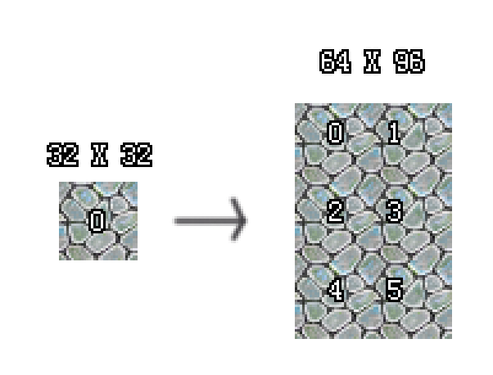

2) Add a new layer. Draw borders and convex & concave

edges(LR UD CV CC).

And paste them to the main tile.

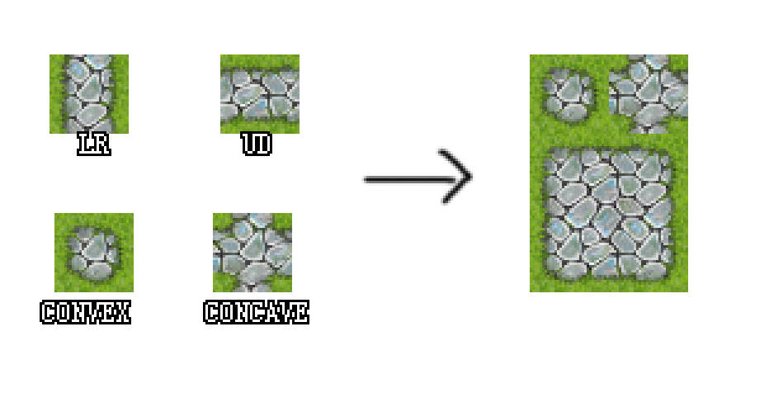

3) Save the finished tile to png.

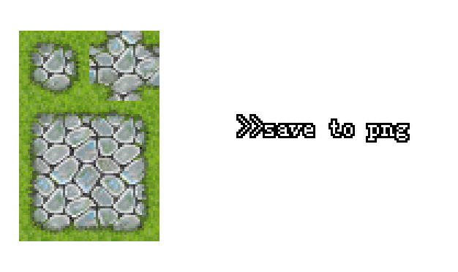

4).Open Tile Prefab Creator in Unity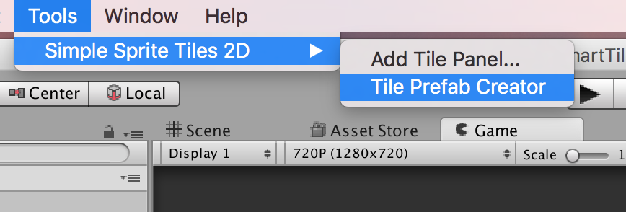

5) Add the texture to Tile panel , Set tile size and pixelperunit

Then press [Edit Texture]

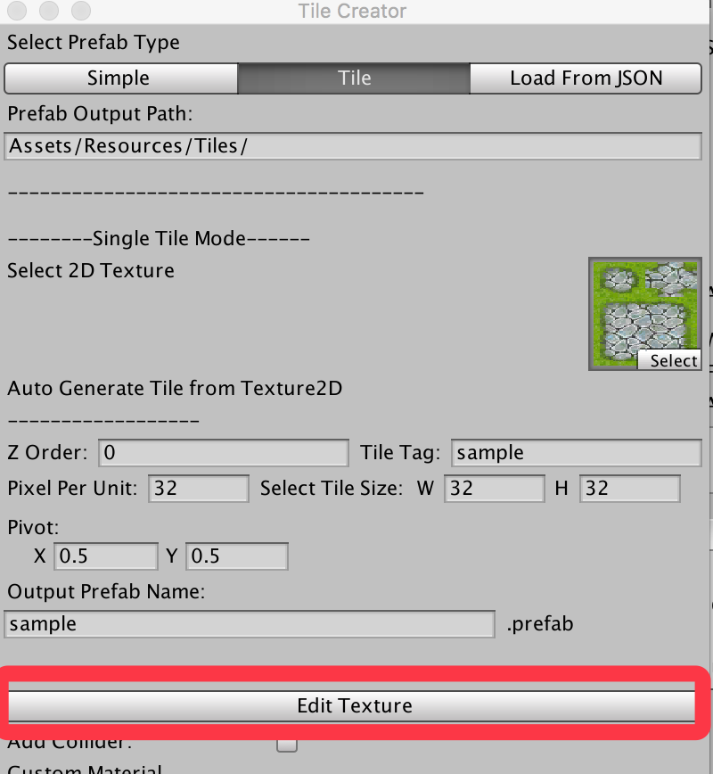

Make Sure, the sprites are all correct.

Then Press [Create Prefab].

6)Add A Tile Panel to Scene ,rename it.



Drag the prefab to scene and set them under the panel object.

Then use CTRL+D(COMMAND+D in macOS) and move them in the scene editor.

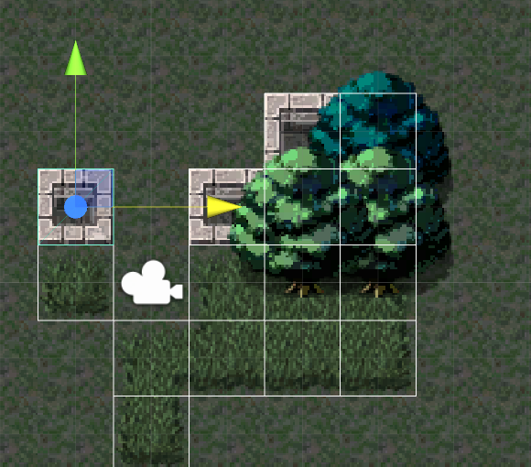 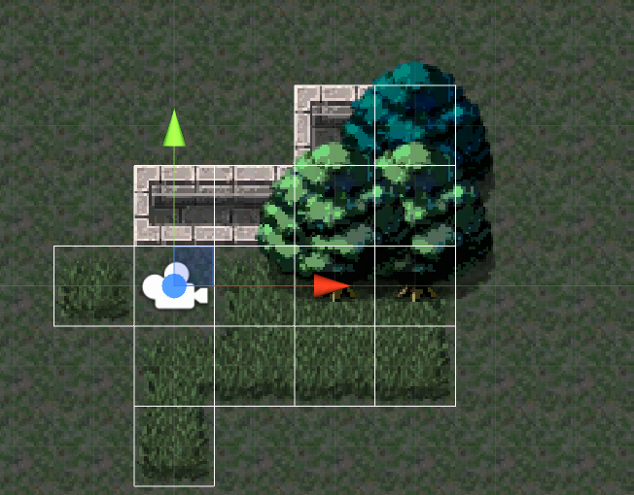

(Tiles will automatically update by the editor)

7. About the Sorting Order

If you want to fix the Sorting Order in scene, Press the Tile Panel GameObject in Scene,set the Layer name ,and do Update Order.

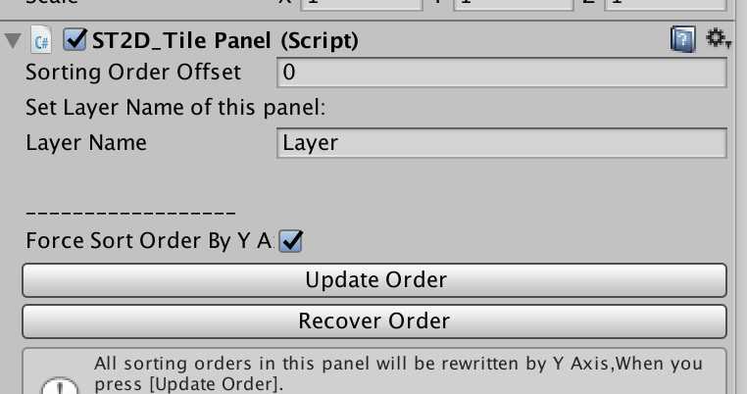

Then all sprites under the panel will be fixed by Y Axis.

10) About the Multiple JSON mode

There is an Example at Assets/SimpleSpriteTile2D/Sample/sample.json.

and Assets/SimpleSpriteTile2D/Scripts/JsonBuilder

I wrote a simple code to show how json template made for multi-prefabs building.

You can write more tile infos into the json template.

The Editor will create prefabs automatically.